Operating Systems Programming Assignment Unit 6

Anonymous Student

University of the People

Operating Systems Programming Assignment Unit 6

This report discusses a paging example in which a virtual address space is converted to a physical address space. The following system criteria are given:

* 4GB(32-bit) virtual address space.
* 1GB of physical space
* 1 MB page sizes.

To answer the assignment questions below, it was necessary to conceptualize the virtual address space and its various segments. I created the following Google Sheets table based on the ideas from our readings (Arpaci-Dusseau & Arpaci-Dusseau, 2012) as well as the video provided to us the first week of class on using masks (The Networking Doctors, 2012):

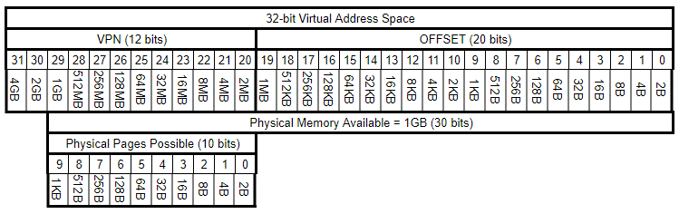

**1. How many virtual pages are there in the address space? 4096**

As you can see in the table above, there are 12 bits in the VPN segment. Therefore, the number of virtual pages possible in the address space are 212, or 4096.

**2. How many physical pages are there in the address space? 1024**

In the table above, you can see that 1GB of physical space would only allow for 10 bits of the VPN to be used for physical pages. Therefore there must be 210, or 1024, physical pages.

**3. How many bits are there in the offset? 20**

The assignment tells us that the pages size is 1MB. As you can see in the table above, 1MB corresponds to 20 bits (counting from right to left, starting at 0).

**4. How many bits are there in the virtual page number? 12**

Since the offset is 20 bits, the remaining bits to the left of the offset are the bits used when indexing the virtual pages. 32 total bits minus 20 offset bits = 12 remaining bits on the left for the virtual page numbers.

**5. How many bits are there in the physical page number? 10**

Since the physical space is only 1GB out of the 4GB virtual space, only 10 of the 12 virtual page number bits can be physical page numbers (when you count 30 bits from right to left, starting at 0).

**6. Translate virtual address 0x410423 to a physical address.**

We are told that all of the page table values are in hex. Below is another Google Sheets table that I created, with the additional steps added based on the ideas from our readings (Arpaci-Dusseau & Arpaci-Dusseau, 2012):

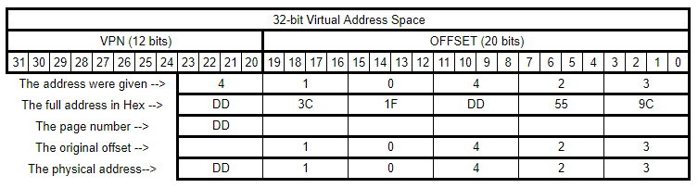

My table shows how I conceived of the virtual address space 0x410423 in hex. I used the hex/value table given to us in the assignment to translate to hex values. Then I transformed the hex values to a physical address by keeping the old offset values and replacing the original VPN value with the new hex value.

**Conclusion**

This week, we were asked to translate a virtual space address to a physical space address. To do this we needed to follow the procedures described in our reading (Arpaci-Dusseau & Arpaci-Dusseau, 2012). First, we needed to understand how to segment a virtual address space into a VPN and an Offset. We also needed to find out which bits we could use to index a physical address space. Lastly we needed to demonstrate how to translate a virtual address space to a physical address space by leaving the offset alone and only transforming the page number from a VPN to a PPN (PFN). By doing this assignment, I definitely understand the process better and feel more confident in doing a VPN to PPN translation.

References

Arpaci-Dusseau, R. & Arpaci-Dusseau, A. (2012). *Operating Systems: Three Easy Pieces. Madison, WI: University of Wisconsin-Madison.* Retrieved from <http://pages.cs.wisc.edu/~remzi/OSTEP//>

The Networking Doctors (2012). IP Addresses and Subnetting. *YouTube*. Retrieved from <https://youtu.be/rs39FWDhzDs>